Greetings,
We are happy to announce that Palo Pinto General Hospital and your school are partnering to provide school-based telemedicine services for our students. Having access to a medical provider at any time during the school day is a win-win for us all. This news, as exciting as it is, may raise many questions for you as parents and guardians. Rest assured, we will do our best to answer each of those questions and alleviate any concerns you may have.
First and foremost, you as the parent/guardian will join the telemedicine visit via your iPhone/Android cell phone, or in person if preferred. If for some reason you cannot be present, permission will still be mandatory for each visit. The school nurse will remain with your child and help facilitate the visit via specialized telemedicine equipment.
Once the provider has completed your child’s assessment, they will make the determination as to whether or not the child may remain at school or if they truly need to be sent home. Our goal is to keep our children in front of the teacher in the classroom setting as that is where the best opportunity to learn takes place. A letter with information on how to access the visit record, and who to contact should there be any questions or concerns will be sent home with your child. Also, a copy of the visit record will be sent to your child’s primary care physician.
You will be asked to sign consents for your child to participate in telemedicine consults, applicable consents for the PPGH clinic network, and also to complete a health questionnaire for your child that the provider can reference when completing their assessment. Insurance will be filed, and co-payments/co-insurance or balances may be billed after the visit. Payments can be made electronically, by phone, or by mail, and instructions will be included with the bill.
We look forward to the upcoming school year and the opportunity to provide telemedicine services to our students. Our students’ health and wellbeing are key to their success in school. Together we can achieve that success.
If you have any further questions, feel free to contact the Palo Pinto Cares for Kids Telehealth Coordinator, Kelli Glover, at 940-328-7588.
Respectfully,
Your care team at Palo Pinto General Hospital & Your School

*Please keep this copy*
School-Based Telehealth Visits
Adapted from AHRQ – Agency for Healthcare Research and Quality

What is telehealth?
- Telehealth is a way to visit with healthcare providers, such as your doctor or nurse practitioner.
- Your child, along with the nurse, can talk to the provider from school, and you can join from work or your home. You don’t go to a clinic or hospital.

How do I use telehealth?
- You talk to the provider by phone, computer, or tablet.
- You will use video so you and your provider can see each other.

How does telehealth help?
- Your child does not have to leave school to go to a clinic or hospital to see a provider.
- You won’t miss work to take your child to see a provider.

Are there any negative affects when using telehealth?
- You and your provider won’t be in the same room, so it may feel different than an office visit.
- Although uncommon, your provider may make a mistake because they cannot examine you as closely as at an office visit. (We don’t know if mistakes are more common with telehealth visits.)
- Your provider may decide you still need an office visit.
- Technical problems may interrupt or stop your visit before you are done.

Will the telehealth visit be private?
- We will not record visits with your provider.
- If you choose to join the visit, please be aware that if people are close to you, they may hear something you did not want them to know. You should be in a private place, so other people cannot hear you.
- Your provider will tell you if someone else from their office can hear or see you.
- We use telehealth technology that is designed to protect your privacy.
- If you use the Internet for telehealth, use a network that is private and secure.
- There is a very small chance that someone could use technology to hear or see your telehealth visit.

How much does a telehealth visit cost?
- What you pay depends on your insurance.
- A telehealth visit will not cost any more than an office visit.
- If your provider decides you need an office visit in addition to your telehealth visit, you may have to pay for both visits.

What does it mean if I sign the following document?
- If you sign the following document, you agree that:
- We provided the information in this document.
- We answered all your questions, or gave you contact information for any remaining questions. (PPGH Telehealth Coordinator, 940-328-7588)
- You want your child to have access to telehealth visits.
- If you sign the following document, we will give you this copy of the information included.
- A record of your child’s visit will be sent to the PCP provided.
Permission for School-Based Telehealth Visits
Adapted from AHRQ – Agency for Healthcare Research and Quality

What is telehealth?
- Telehealth is a way to visit with healthcare providers, such as your doctor or nurse practitioner.
- Your child, along with the nurse, can talk to the provider from school, and you can join from work or your home. You don’t go to a clinic or hospital.

How do I use telehealth?
- You talk to the provider by phone, computer, or tablet.
- You will use video so you and your provider can see each other.

How does telehealth help?
- Your child does not have to leave school to go to a clinic or hospital to see a provider.
- You won’t risk getting sick from other people.
- You won’t miss work to take your child to see a provider.

Are there any negative affects when using telehealth?
- You and your provider won’t be in the same room, so it may feel different than an office visit.
- Although uncommon, your provider may make a mistake because they cannot examine you as closely as at an office visit. (We don’t know if mistakes are more common with telehealth visits.)
- Your provider may decide you still need an office visit.
- Technical problems may interrupt or stop your visit before you are done.

Will the telehealth visit be private?
- We will not record visits with your provider.
- If you choose to join the visit, please be aware that if people are close to you, they may hear something you did not want them to know. You should be in a private place, so other people cannot hear you.
- Your provider will tell you if someone else from their office can hear or see you.
- We use telehealth technology that is designed to protect your privacy.
- If you use the Internet for telehealth, use a network that is private and secure.
- There is a very small chance that someone could use technology to hear or see your telehealth visit.

How much does a telehealth visit cost?
- What you pay depends on your insurance.
- A telehealth visit will not cost any more than an office visit.
- If your provider decides you need an office visit in addition to your telehealth visit, you may have to pay for both visits.

What does it mean if I sign this document?
If you sign this document, you agree that:
- We provided the information in this document.
- We answered all your questions, or gave you contact information for any remaining questions. (Telehealth Coordinator, 940-328-7588)
- You want your child to have access to telehealth visits.
- If you sign this document, we gave you a copy of the information included.
- A record of your child’s visit will be sent to the PCP provided.

_______________________________________________
Your Child’s name (please print)

_______________________________________________
Your name (please print)

_______________________________________________ ______________
Your signature Date

Patient Information
Name: DOB: _____ _______ Sex:
Address: Phone:
City, State, Zip: Pharmacy Name:
Allergies: Pharmacy Phone:
Medications currently taking:
Medical/Surgical History:

Parent/Guardian Information (Students only) Emergency Contact
Name: Name:
Address: Address:
City, State, Zip: City, State, Zip:
Daytime Phone: Daytime Phone:
Email: Present by phone/in person for visit? Y / N

School Information Physician Information
Name: Name:
Address: Address:
City, State, Zip: City, State, Zip:
Phone: Phone: Fax:

Insurance Information
Company: Subscriber:
Policy Number: DOB:
Group Number: Social Security Number:
*Please provide copies of insurance card and ID*
(Parent/Guardian ID if patient is a minor)

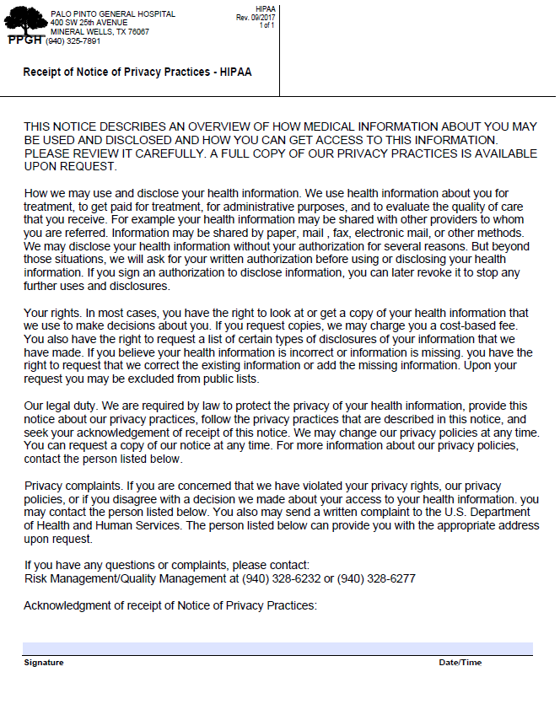

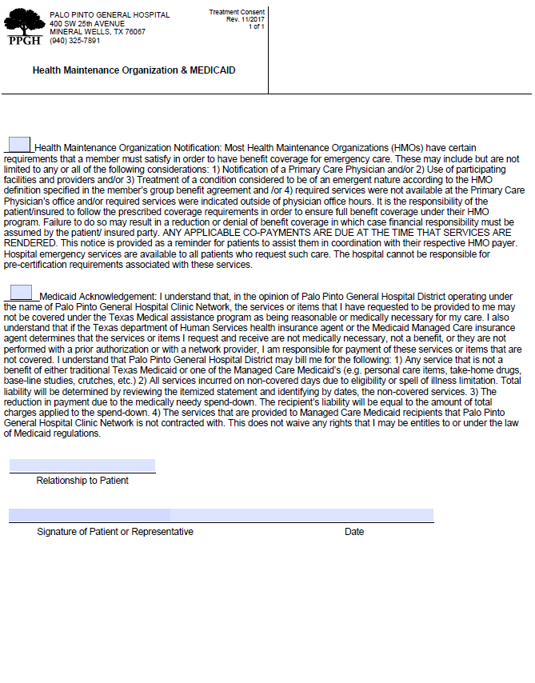

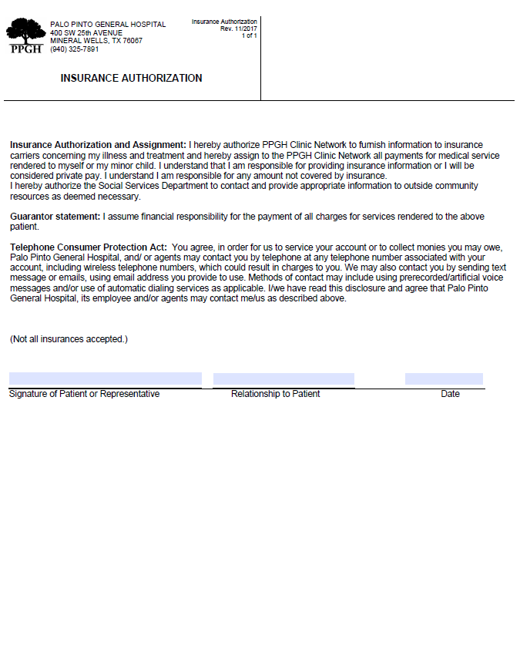

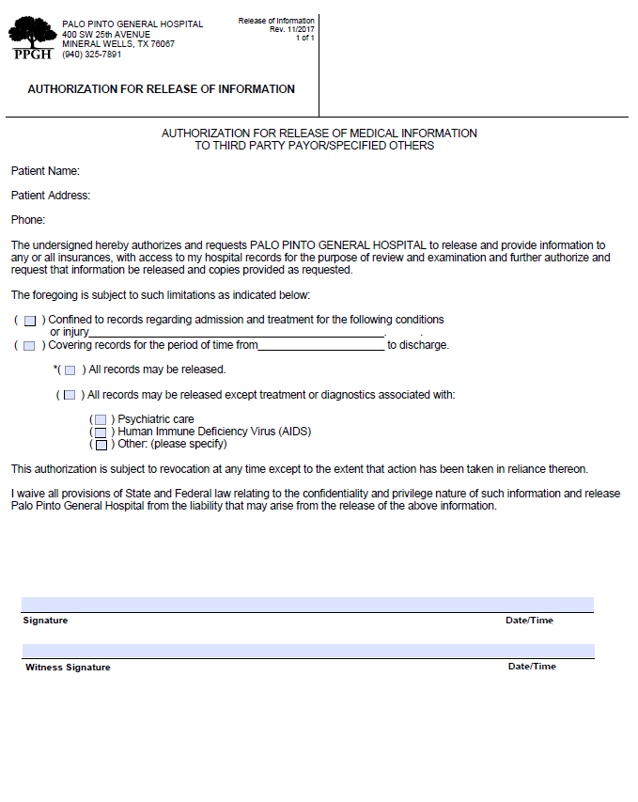

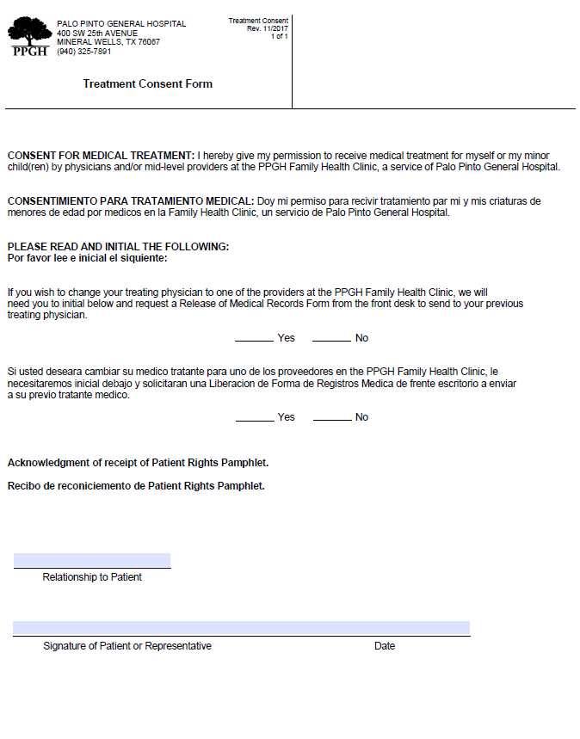

HIPAA AUTHORIZATION FOR USE OR DISCLOSURE OF HEALTH INFORMATION

This form is for use when such authorization is required and complies with the Health Insurance Portability and Accountability Act of 1996 (HIPAA) Privacy Standards.

Print Name of Patient: ___________________________________________________________

Date of Birth: ___________________________ SSN: __________________________________

- My Authorization
Pursuant to Texas Administrative Code, Title 1, Part 15, Chapter 354, Subchapter A, Division 33, Rule §354.1432; for a child receiving telemedicine medical services in a school-based setting, a notification including a summary of the service must be provided to the primary care physician or provider, along with a copy of the summary being provided to the parent/legal guardian.

I authorize Palo Pinto General Hospital to use or disclose my child’s health information.
The above party may disclose this health information to the following recipient:

Primary Care Physician: ___________________________________________________

Address:________________________________________________________________

City ____________________ State ____________________Zip____________________

Phone _____________________________ Fax _________________________________

Physician Email __________________________________________________________

Parent/Legal Guardian Email ________________________________________________

The purpose of this authorization is to provide for communication between my child’s physician and the telemedicine providers at school.

This authorization is in effect for the 2020-2021 school year.

Pursuant to Texas Administrative Code, Title 1, Part 15, Chapter 354, Subchapter A, Division 33, Rule §354.1432; a child receiving telemedicine medical services in a school-based setting, a notification must be provided to the primary care physician or provider.

II. My Rights
I understand that I have the right to revoke this authorization, in writing, at any time, except where uses or disclosures have already been made based upon my original permission. I may not be able to revoke this authorization if its purpose was to obtain insurance. In order to revoke this authorization, I must do so in writing and send it to the appropriate disclosing party.

I understand that uses and disclosures already made based upon my original permission cannot be taken back.

I understand that it is possible that information used or disclosed with my permission may be redisclosed by the recipient and is no longer protected by the HIPAA Privacy Standards.

I understand that treatment by any party may not be conditioned upon my signing of this authorization (unless treatment is sought only to create health information for a third party or to take part in a research study) and that I may have the right to refuse to sign this authorization.

I will receive a copy of this authorization after I have signed it. A copy of this authorization is as valid as the original.

☐ - Patient is a minor: _____________ years of age

Signature of Authorized Representative: _____________________________________________

Date: ________________________

Print Name of Authorized Representative: ___________________________________________

Authority of representative to sign on behalf of the patient: ☐ - Parent ☐ - Legal Guardian
☐ - Court Order ☐ - Other: _______________________________________________________

